SUNY Business Intelligence “BI”
Financial Dashboards

Big Improvement over SMRT

Sandy Noble, Director of University Accounting
Overview:

SUNY System Administration has discontinued SMRT finance system software maintenance. The new tool to be used is the SUNY BI (Business Intelligence) Finance tool. BI uses dashboards created by SUNY Finance/IT with feedback from campuses to replicate or be similar to the tools available in SMRT and SUNY Legacy. It is unclear at this time when SUNY Legacy and SMRT will be completely disabled, but features began to be malfunction or were disable beginning June 2015.

SUNY has been using BI for several years, primarily in Institutional Research & Planning offices. Training videos are available through the Training Dashboard on the BI Tool.

The Finance Data Warehouse has data starting with the Cost Center Fiscal Year 2008-2009 through the most recent data load. SUNY System Administration loads new data nightly.

Financial Dashboards currently available in SUNY BI Finance:
Not everyone has access to all dashboards. Campus Security Administrator sets up access on an individual level basis. Users can only view the accounts that the Director of University Accounting has assigned to them on a group or individual basis.
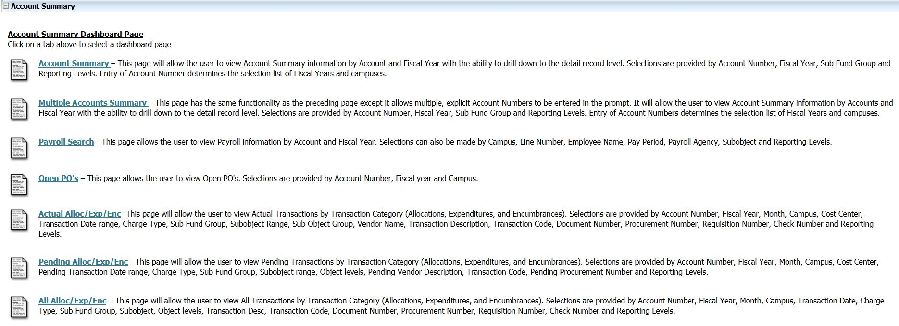
Account Summary:
CF Project Analysis:

Expenditure Inquiry:
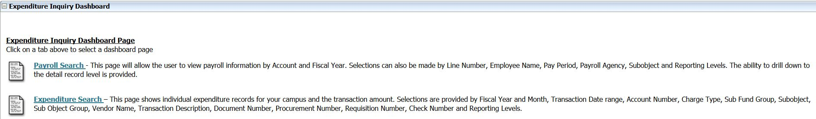
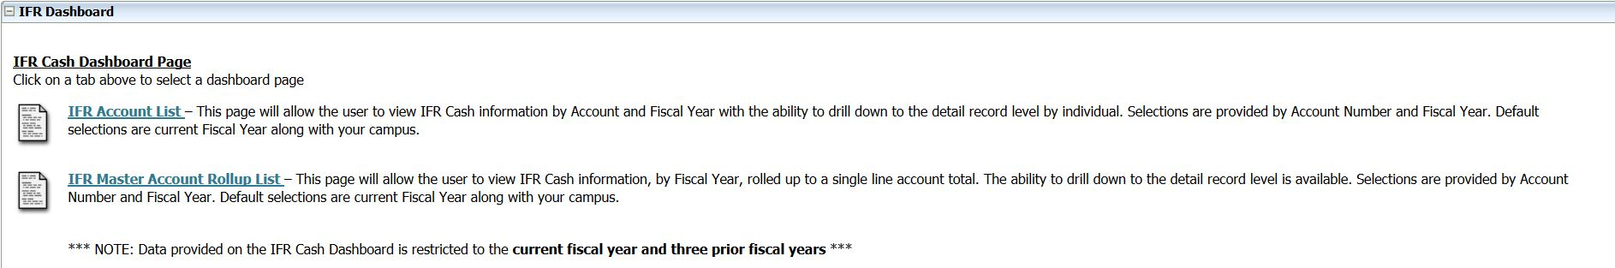
IFR Cash:

Management Summary:
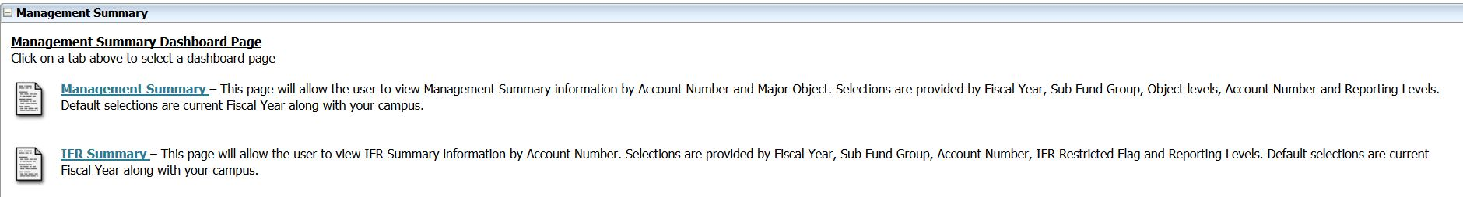

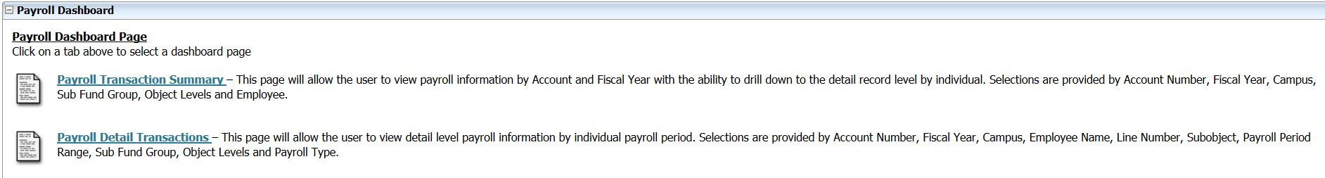
Payroll:

Reference:
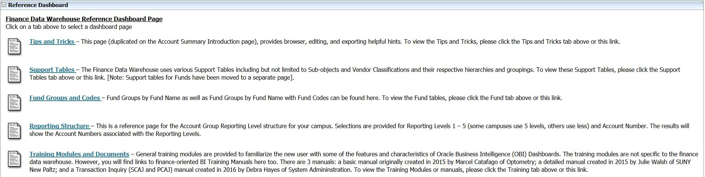

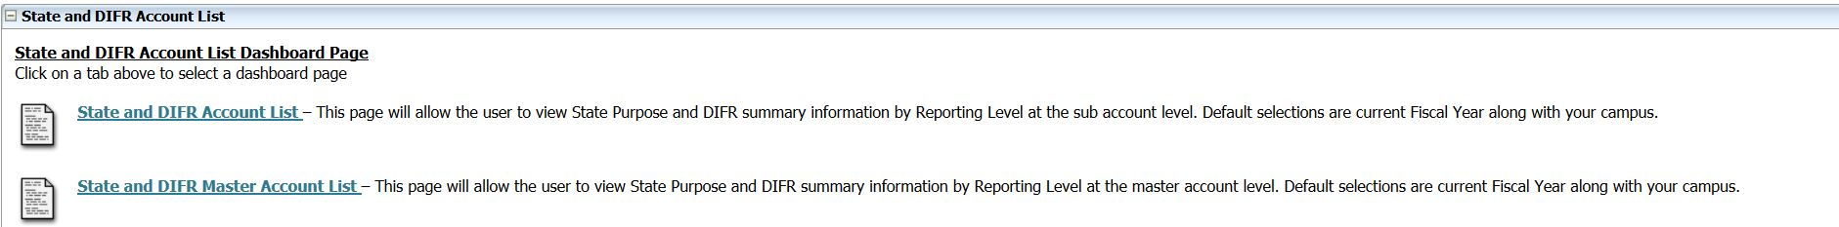
State and DIFR Account List:

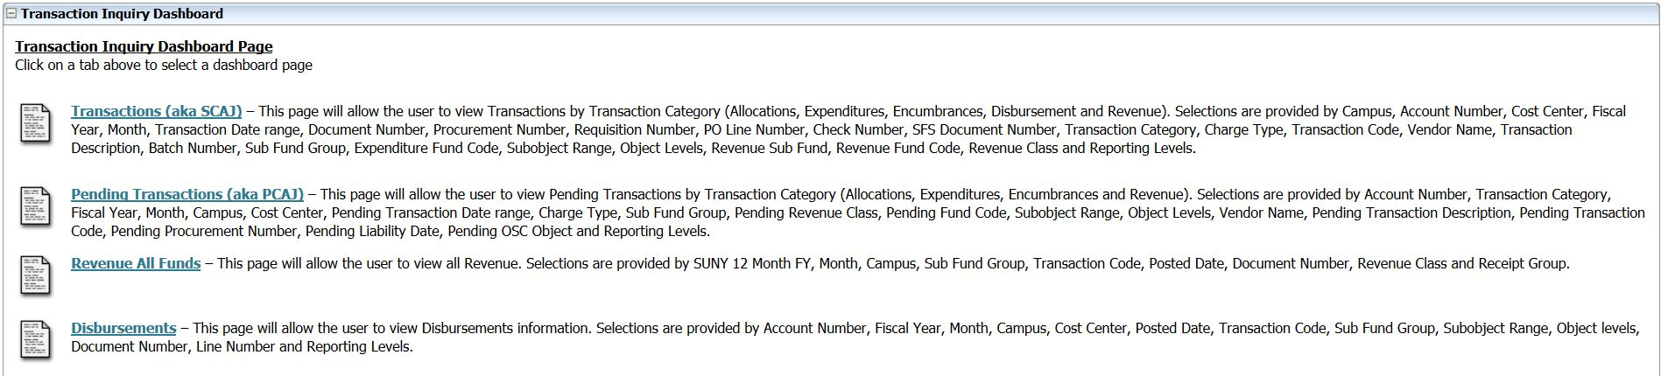
Transaction Inquiry:

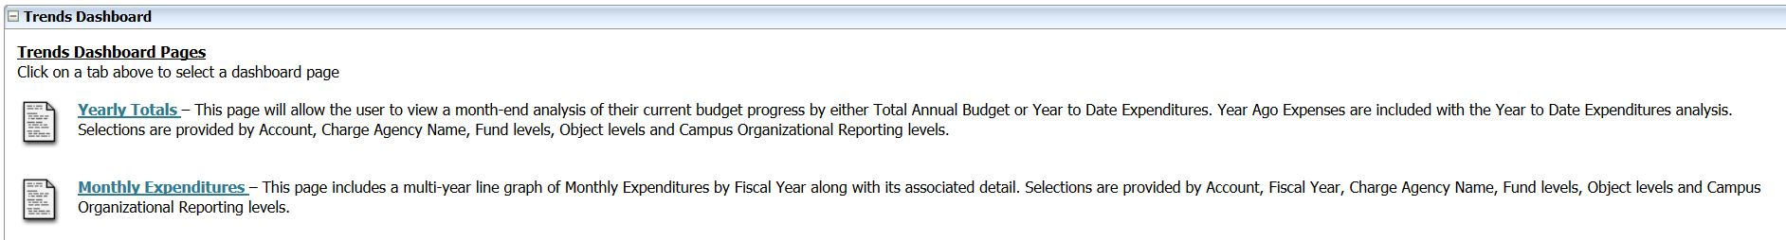
Trends:

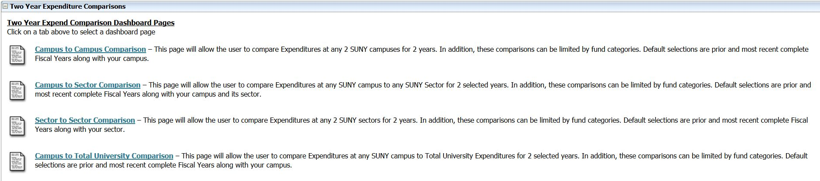
Two Year Expenditure Comparison:
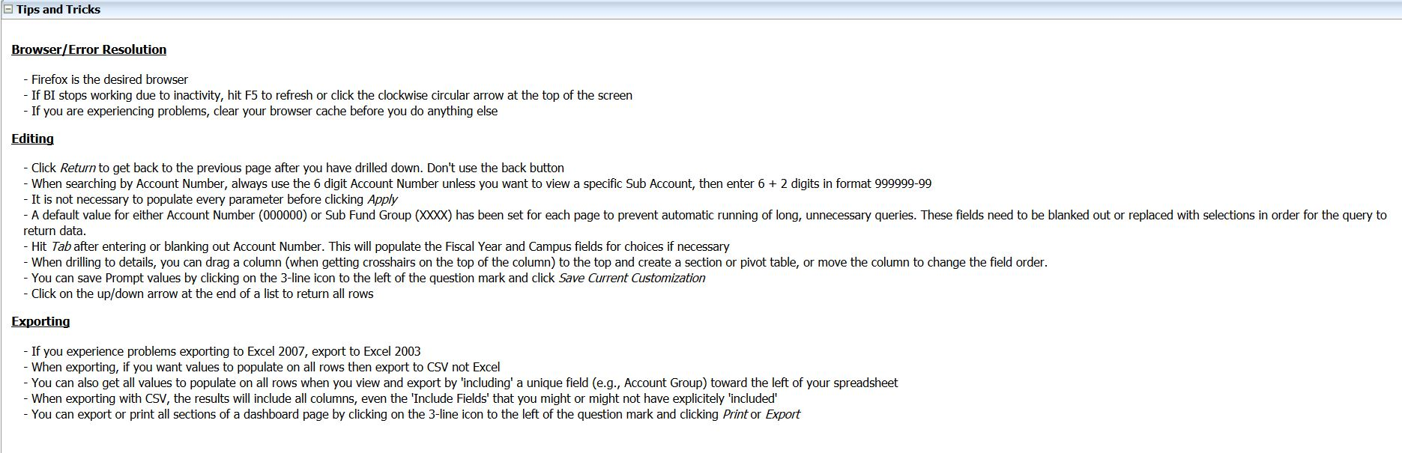
Tips and Tricks:

Getting to SUNY BI:
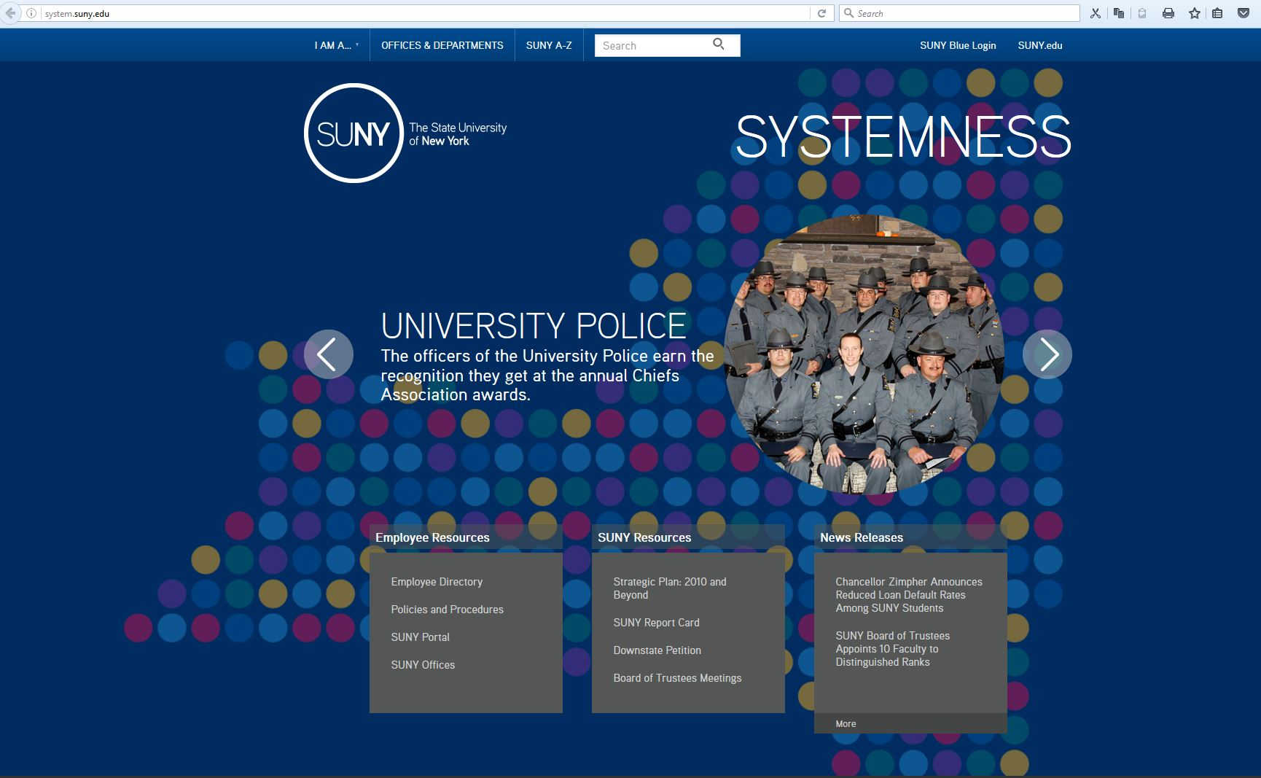
Using Firefox
Log on to SUNY Employee Portal at website www.suny.edu Sign-on using eServices ID / Password
Click on reports

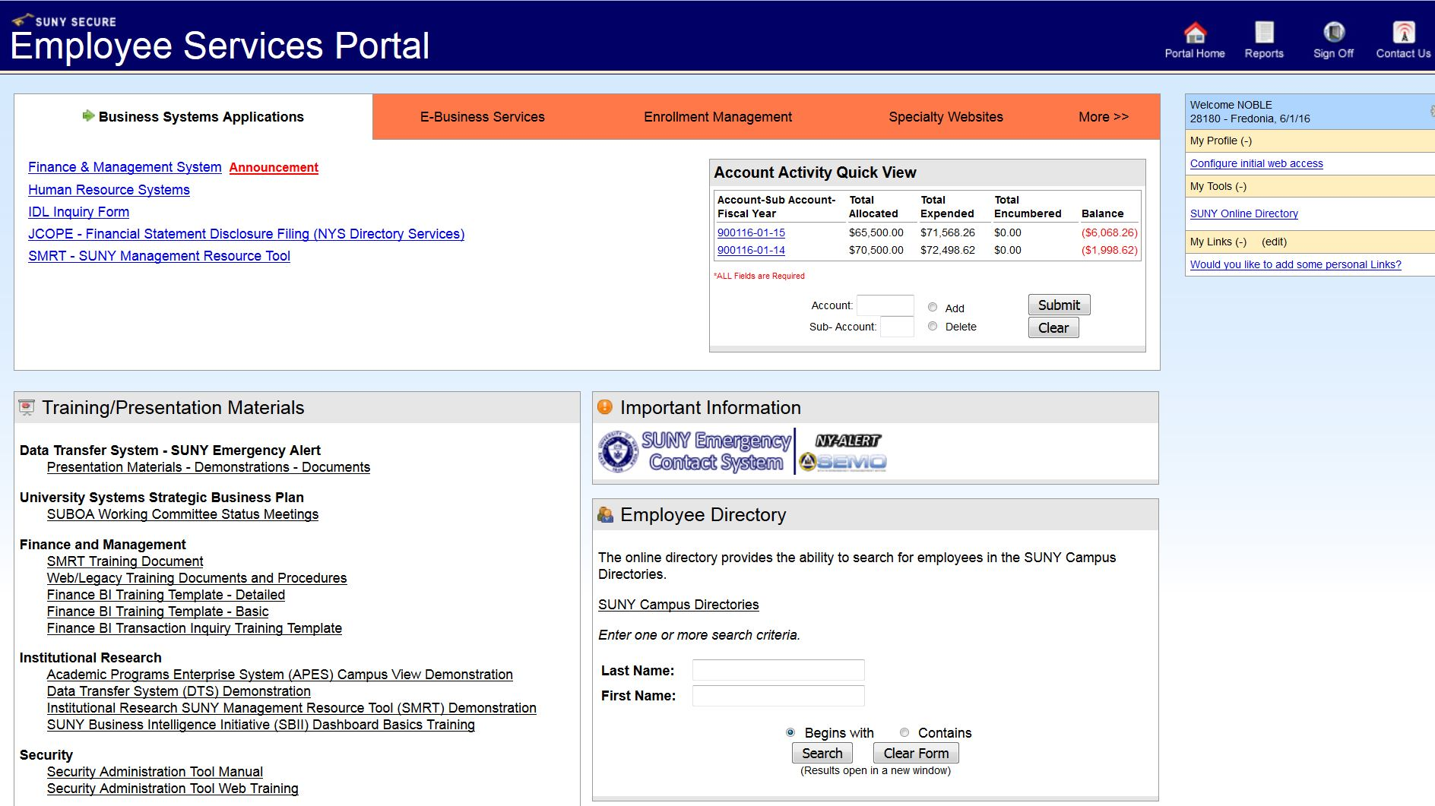

Click on Business Intelligence tab:

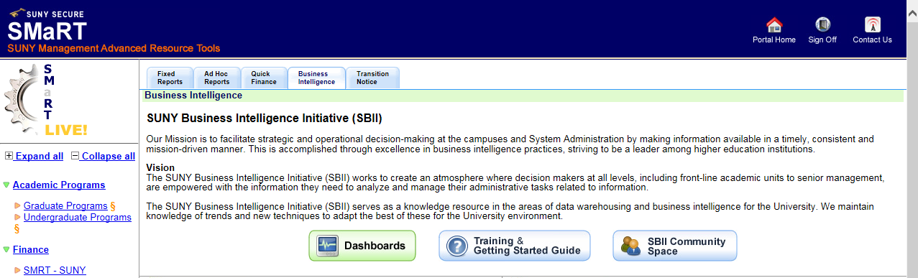

Click on Dashboards box:

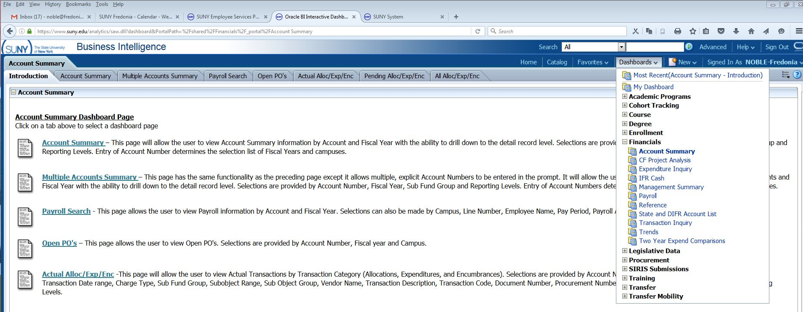
Working with the Account Summary Dashboard:

- Click in Account begins with box; the default is always all zeros. This keeps the system from searching for account data when you first open the page:
  - Type in 6 digit account code, if you are looking for an account WITHOUT subs.
  - Type in 8 digit accounts as such: 900023-01, the “dash” must be included if you are looking at a sub account.
- Tab to Fiscal year, default is current year, but can be changed via drop-down (arrow).

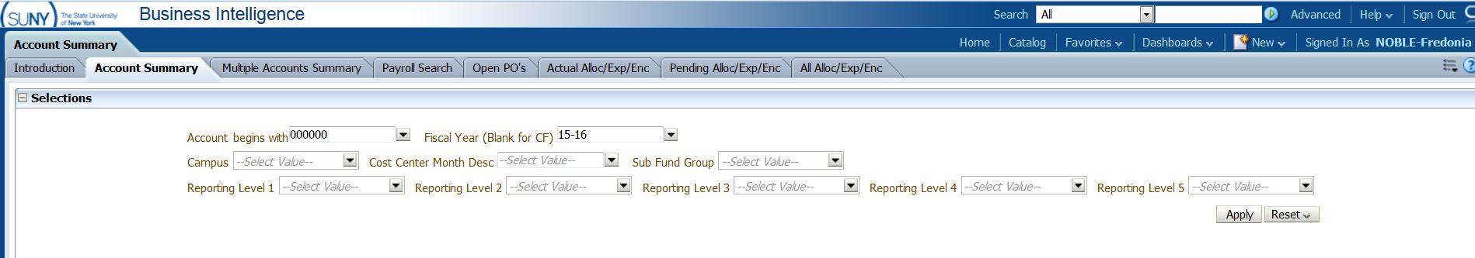

Enter does not work in BI, must click “APPLY” button

Result from BI defaults to “SUMMARY OF MAJOR OBJECTS”

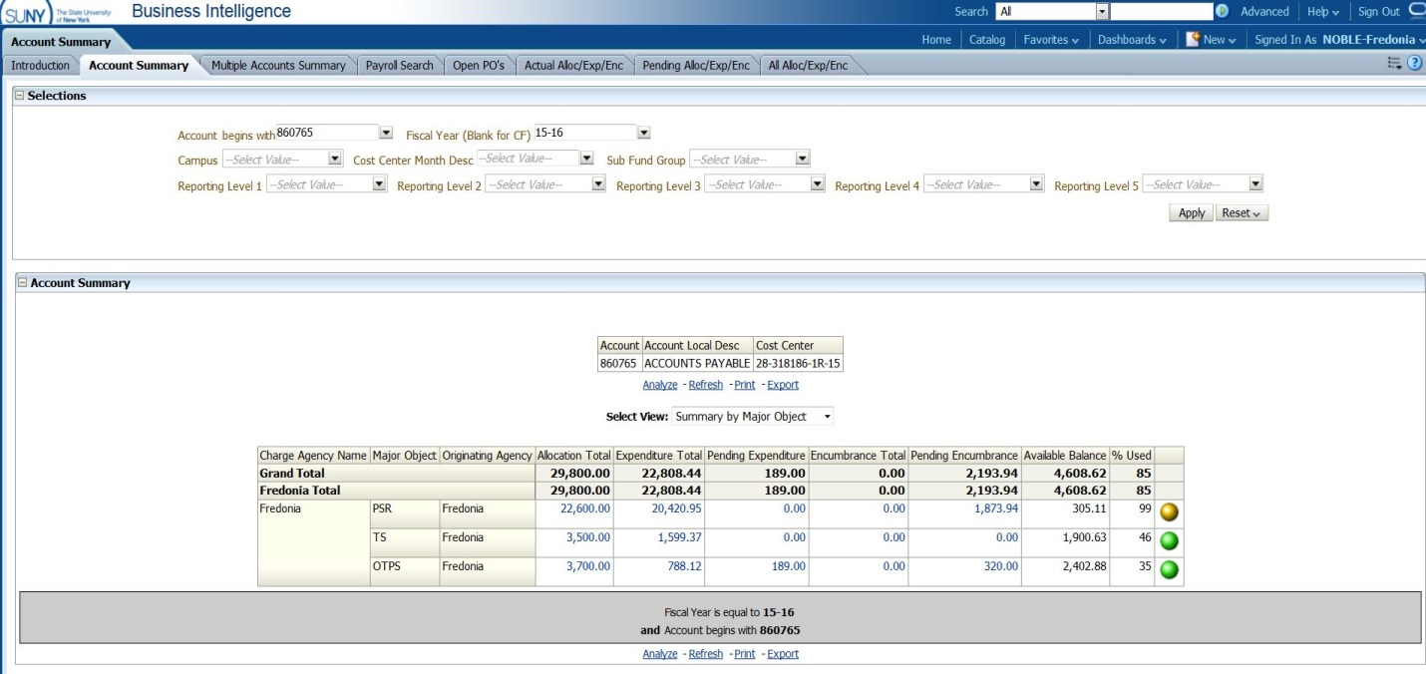

CAUTION: Personal Service (PSR) is included in the default settings. It is highly recommended users utilize the Customization feature to remove PSR. PSR is managed centrally at Fredonia, so divisions/departments when calculating balances should NEVER include PSR.

Result from Customized (excludes PSR) Account Summary Dashboard:
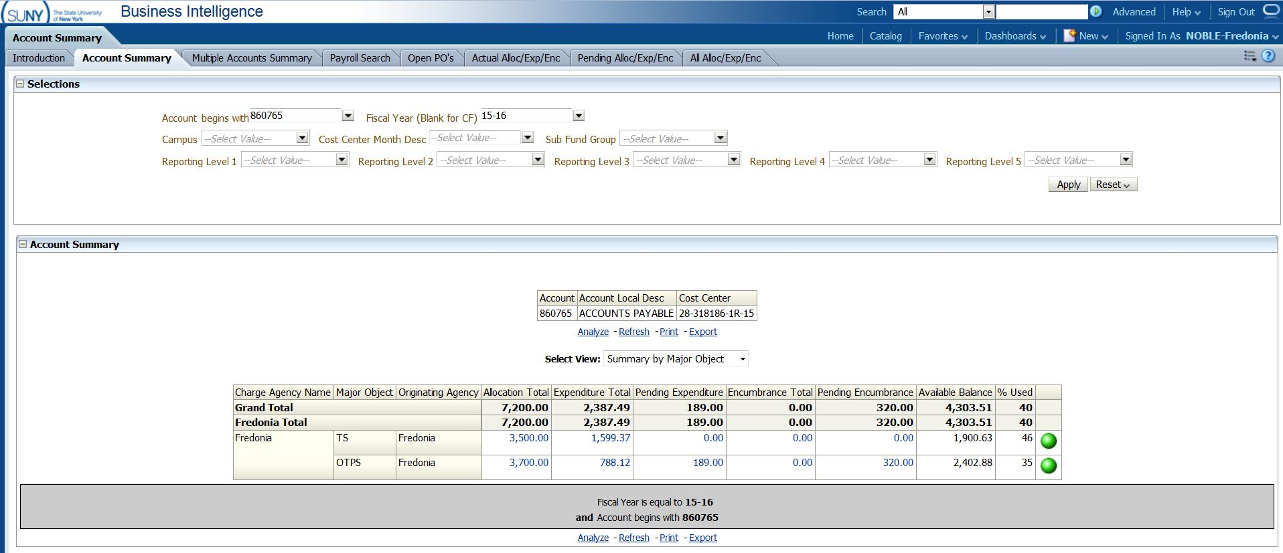

Drop down menu for “Select View” as three options
- Summary by Major Object (default) – may be your easiest option to use
- Summary by Object
- Summary by Detailed Object (most closely reflects look of SMRT)

NOTE: Option 3 calculates Campus Recharges as a separate object in BI. When calculating Available Balance the user will have to add in Recharge Totals.

Summary by Object:

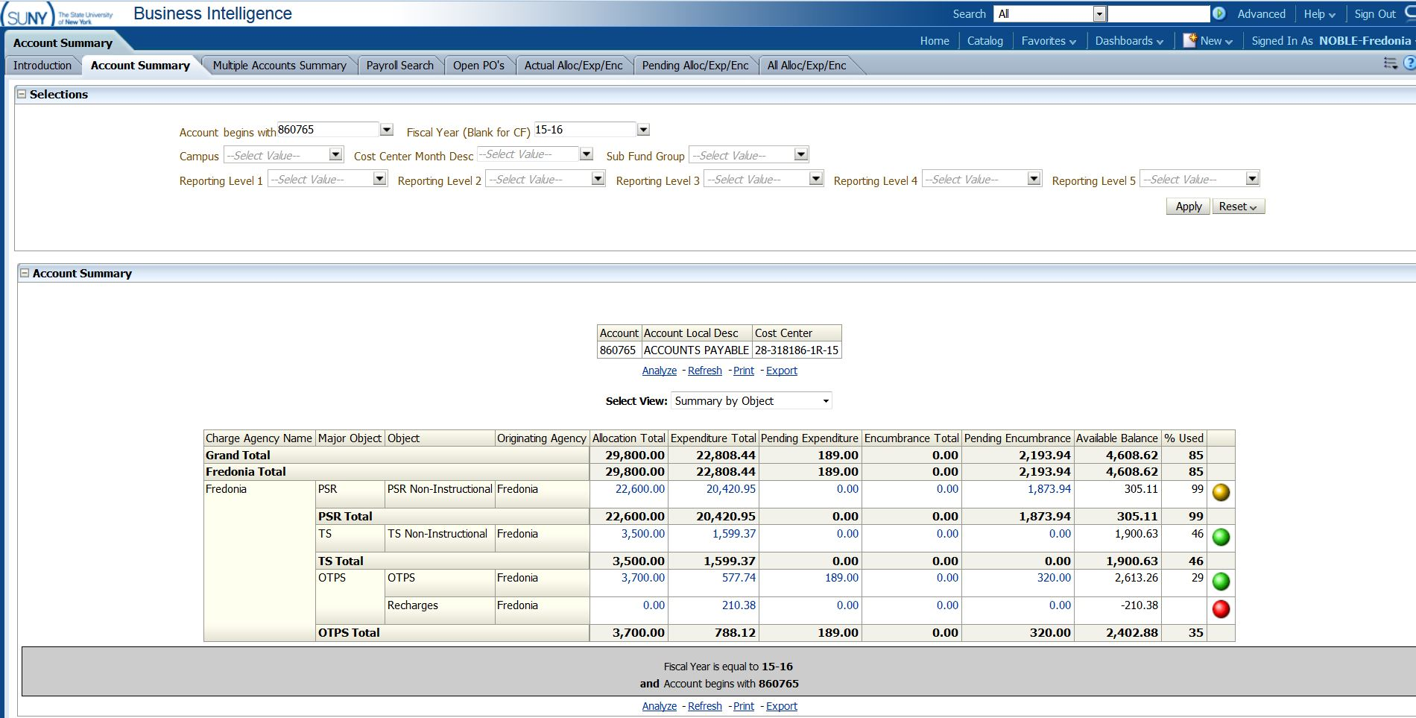

Summary by Detailed Object:

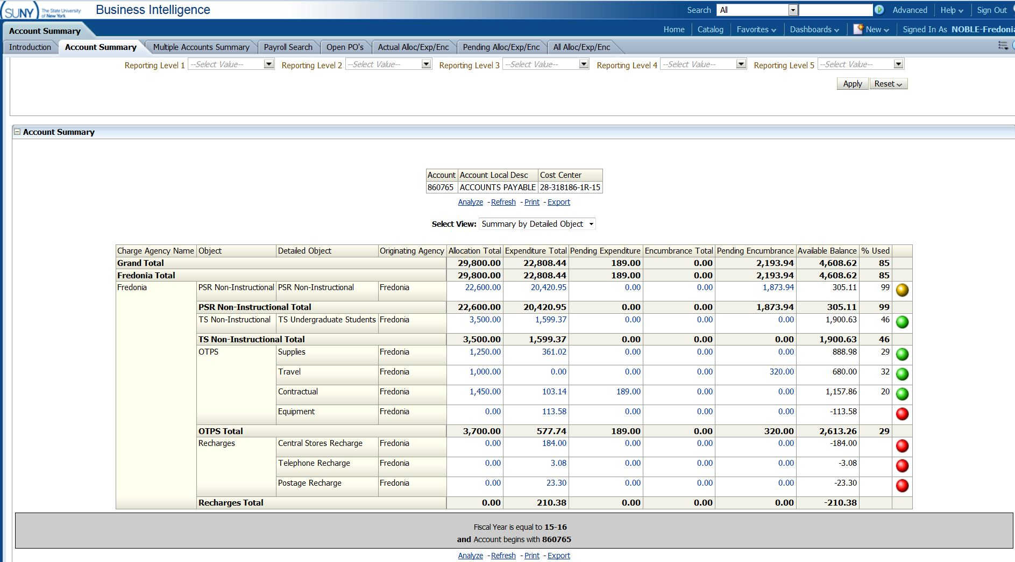

To look at expenditure detail, click on amount, menu will pop-up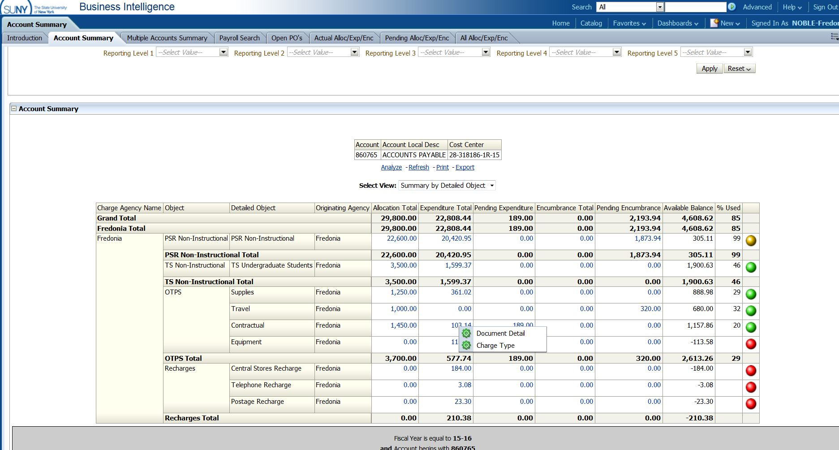

Click on Document Detail: anytime lettering is in Blue, it is a drillable field
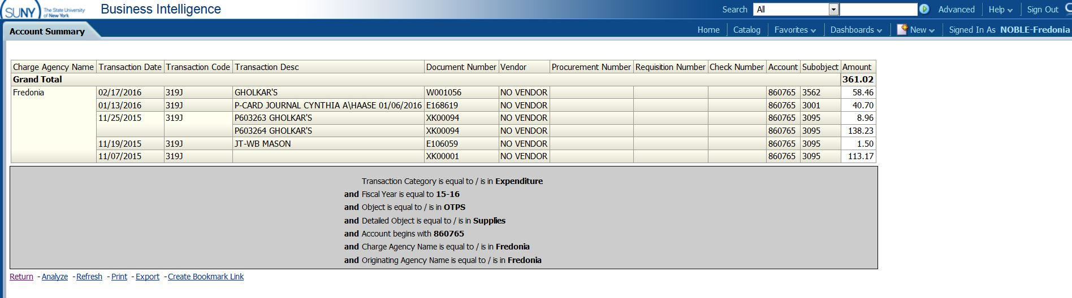
To return to previous page, always click return, do not use “back” button on browser

Charge Type:

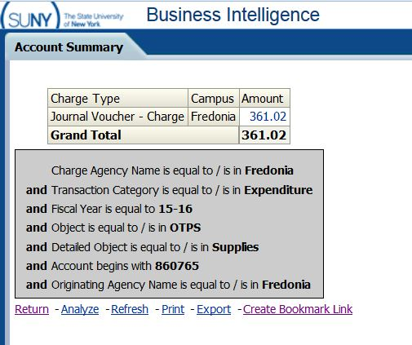
Click on blue clickable number:

Results: can drill down on Document Number & Procurement Number from here as well (if particular charge is drillable)
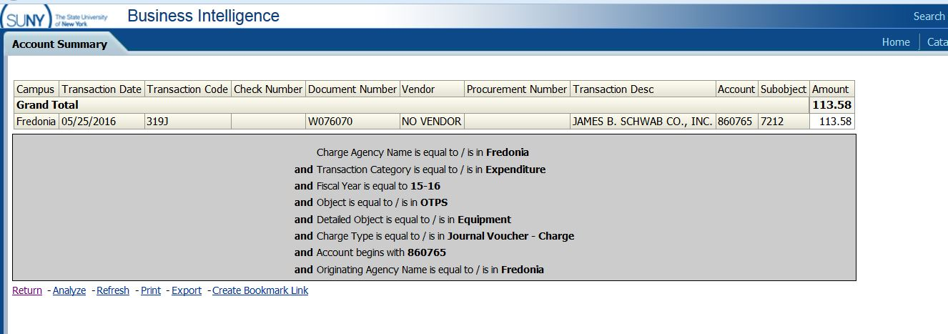

Working with the default IFR Cash Accounts:

- These are cash accounts (the first digit begins with a “9”)
- Their Cash Balances roll forward to the new fiscal year
- Cash Bal less Encumbrance is the field showing the available cash
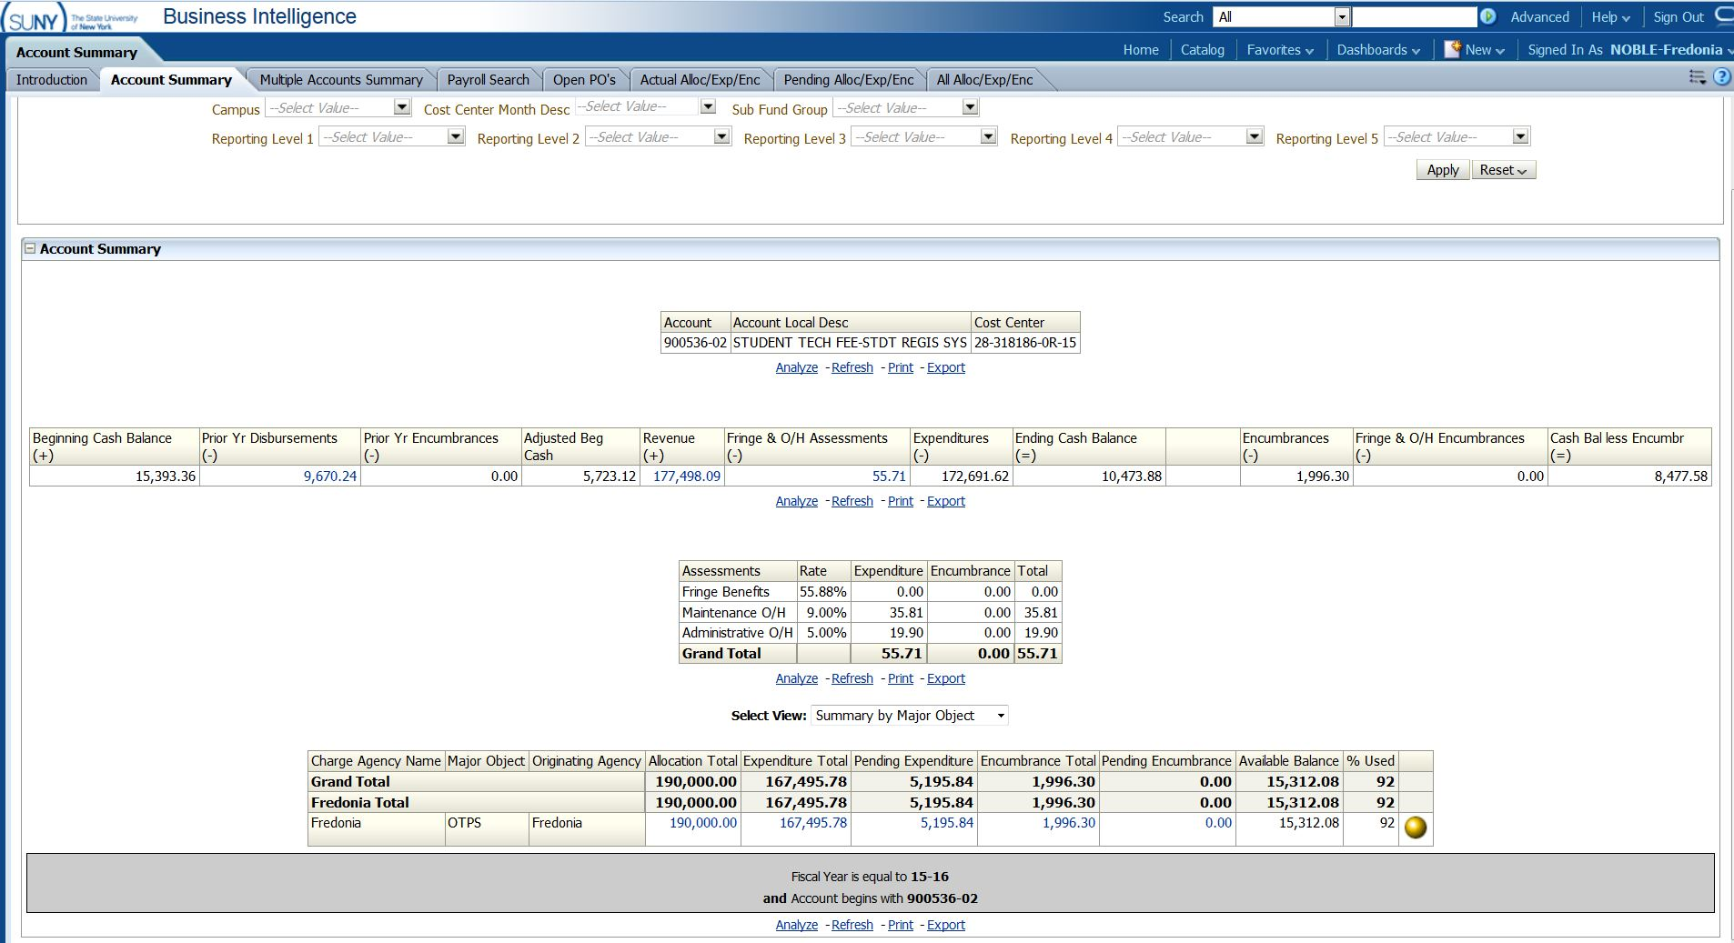

It is highly recommended users utilize the Customization feature to remove any Allocation, PSR, and to show activity for ONLY the current fiscal year.
Result from Customized (prior year and allocation information removed) IFR Cash Dashboard:

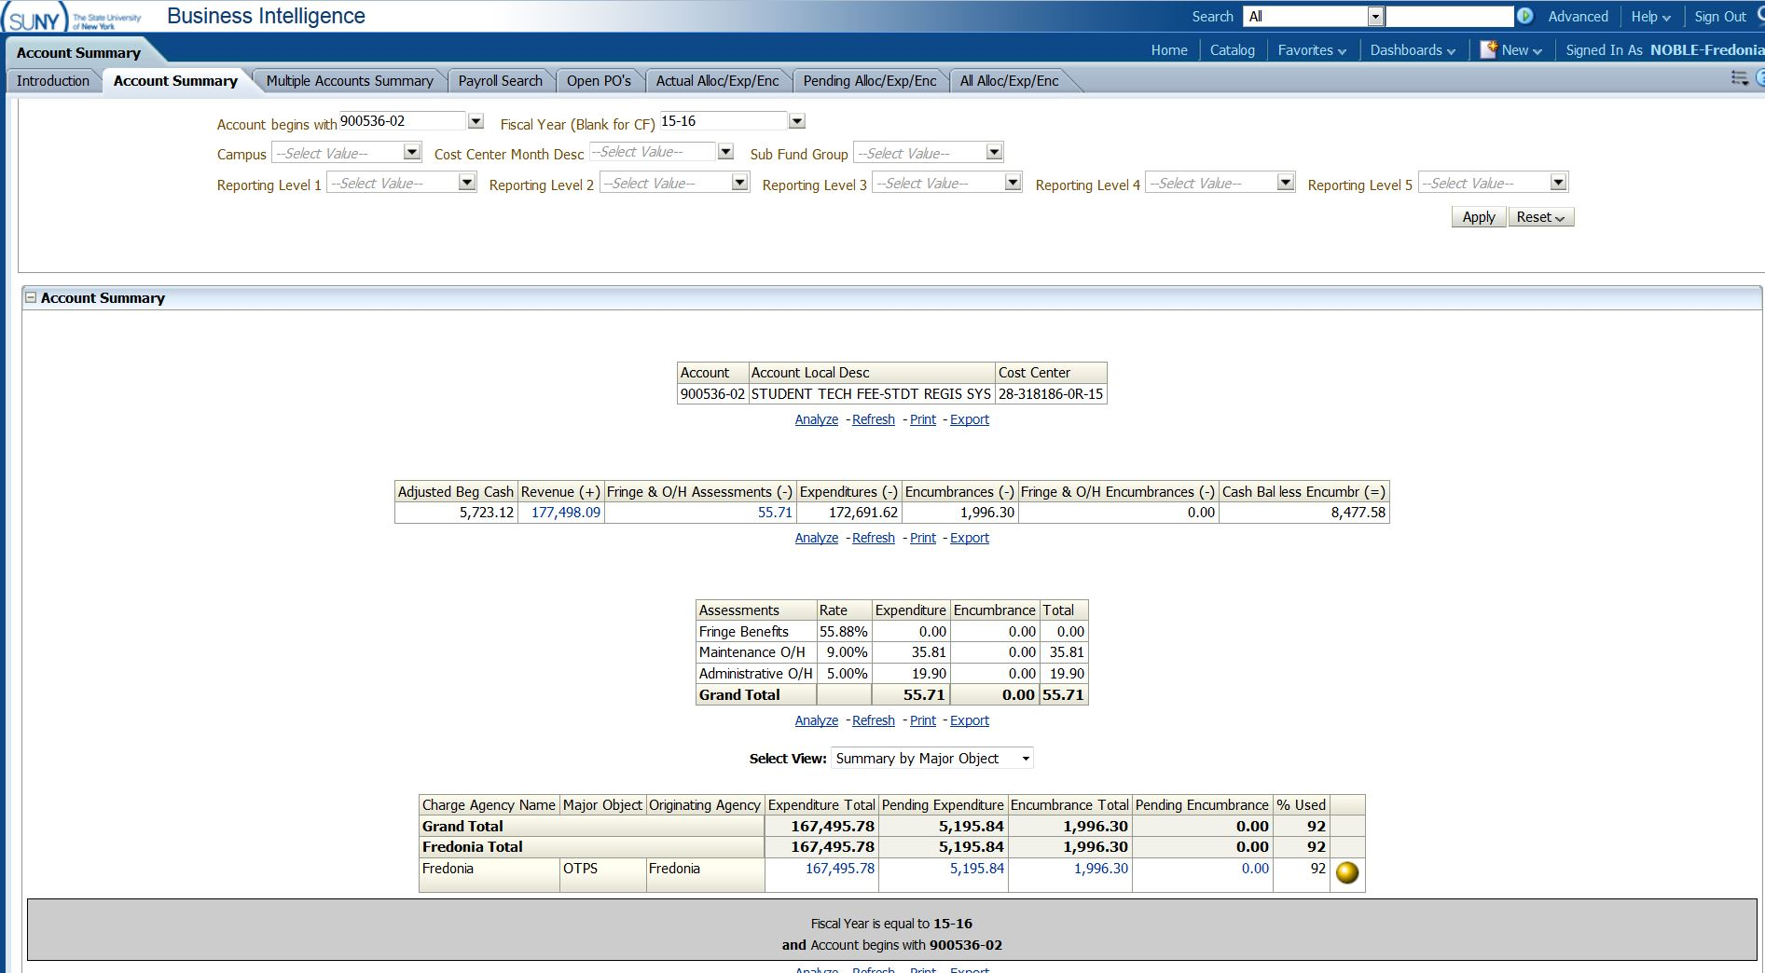

Document Detail (reminder this is available on any blue clickable number):
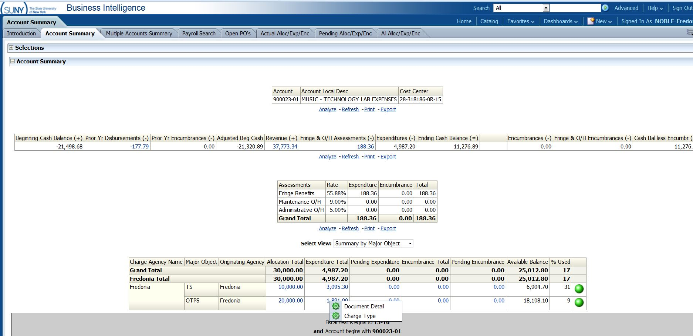

Notice in this Document Detail the blue underlined numbers… by clicking on these links, users can see payment, purchase order, and requisition documents
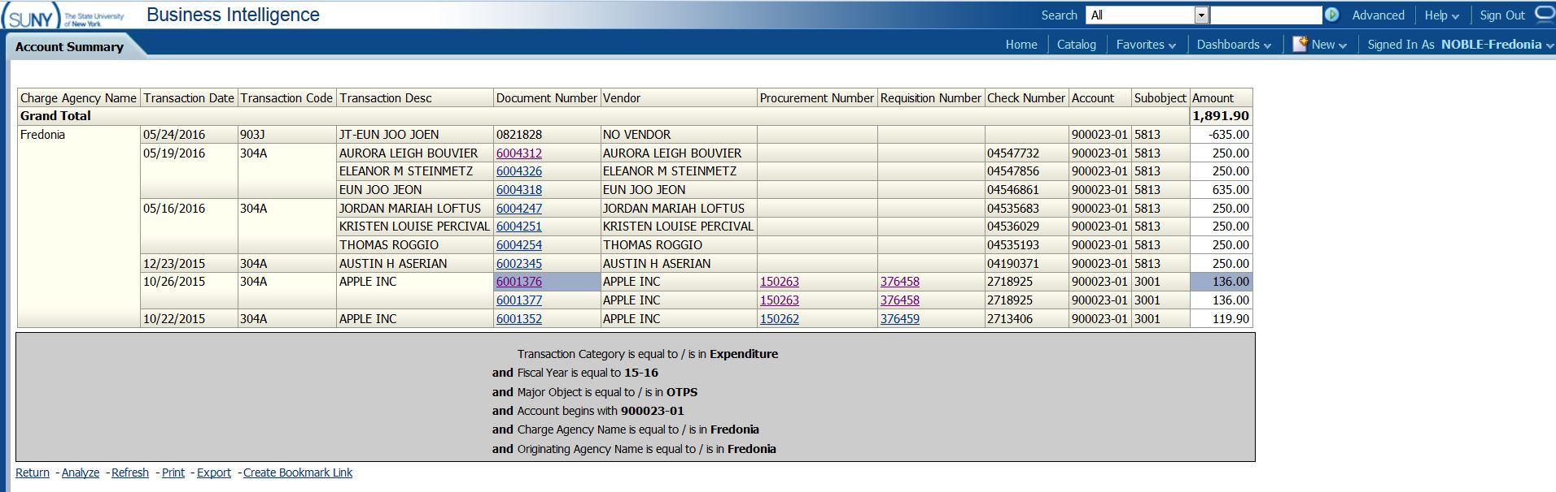

- To save information, you can use print
- Information can also be Exported:
  - Several option exist for export including PDF, Excel (2003 or 2007), Powerpoint (2003 or 2007), data (includes CSV, Tab Delimited, or XML).
    - If you would like to keep all formating, use Excel, if you want data only, use CSV format:

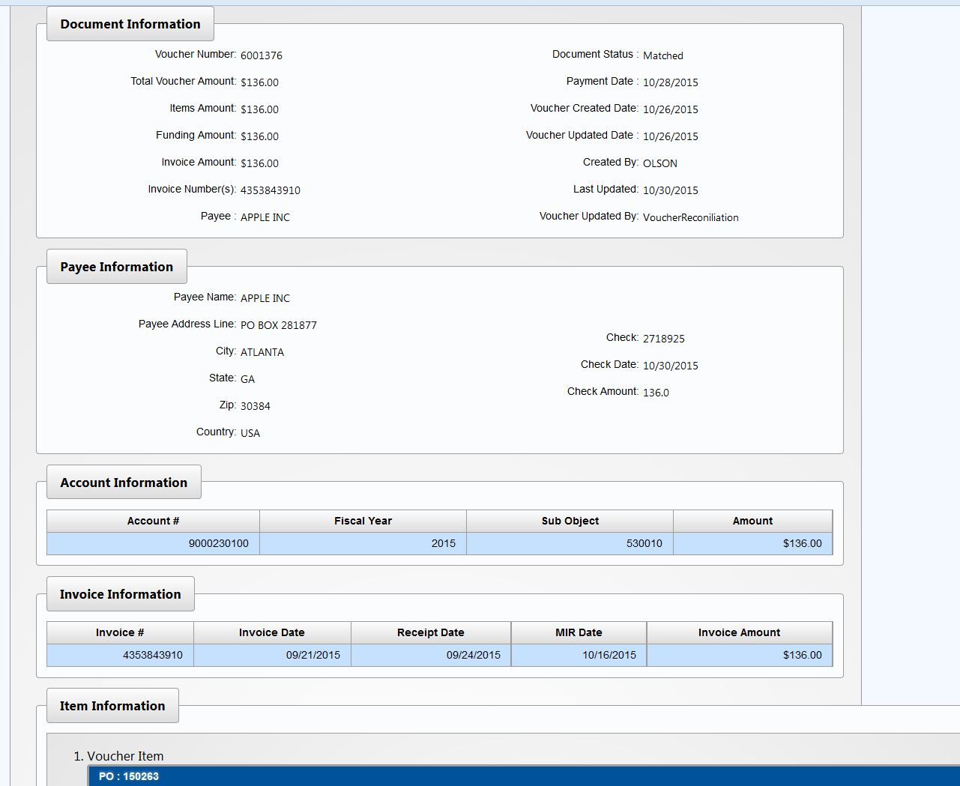Payment in
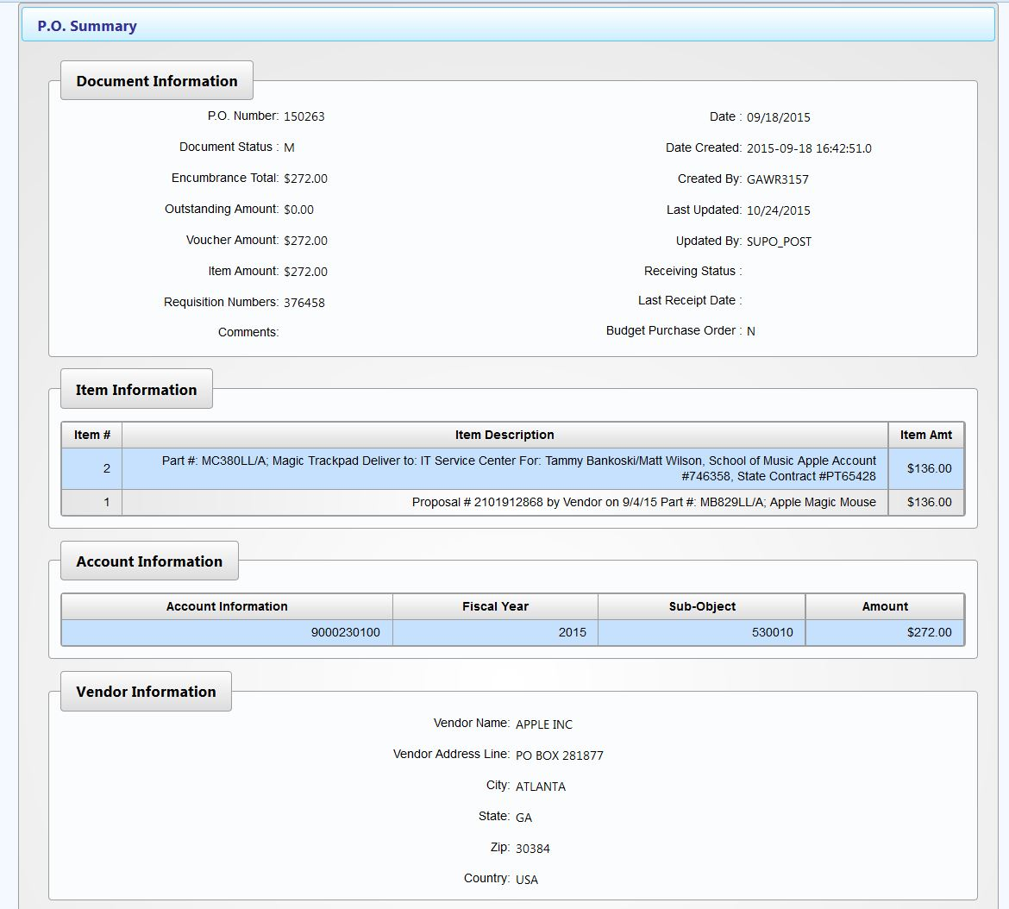
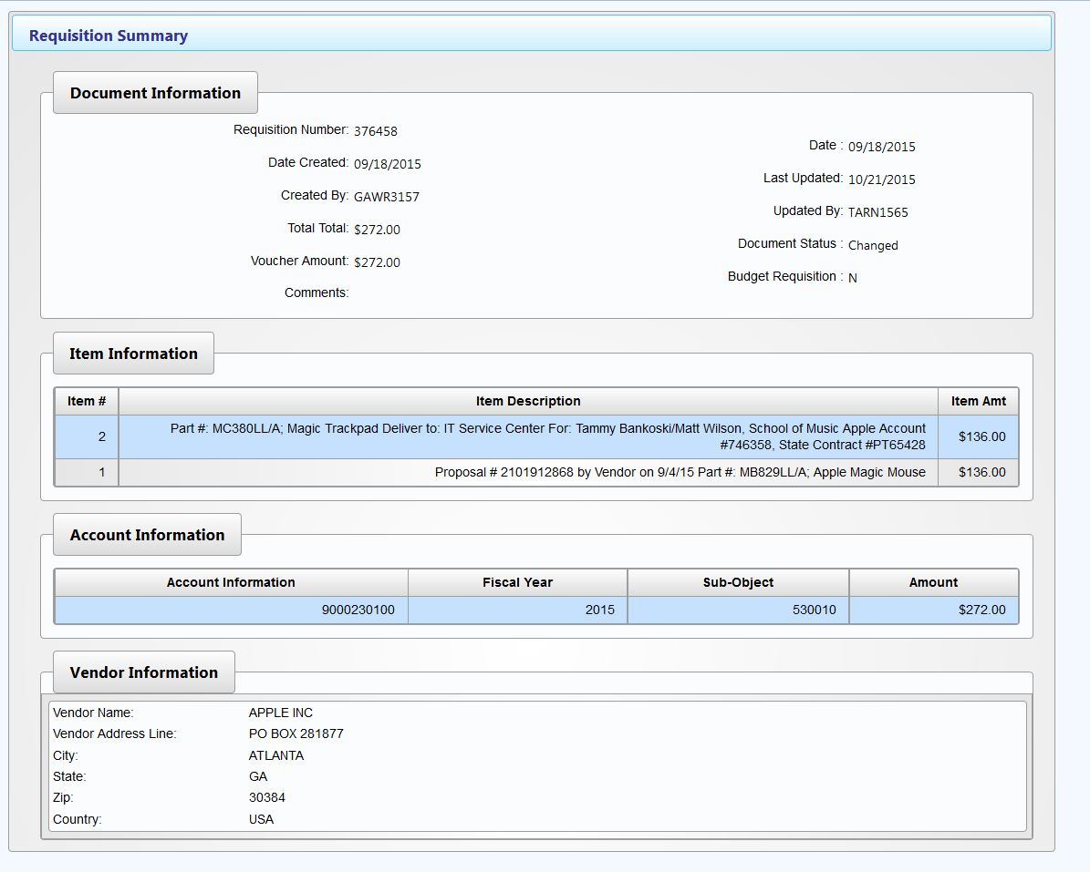
Customizing your dashboards:
Once you have displayed your account the way you want to see it, click on Customization Toolbar [box left of the question mark] located in right hand corner

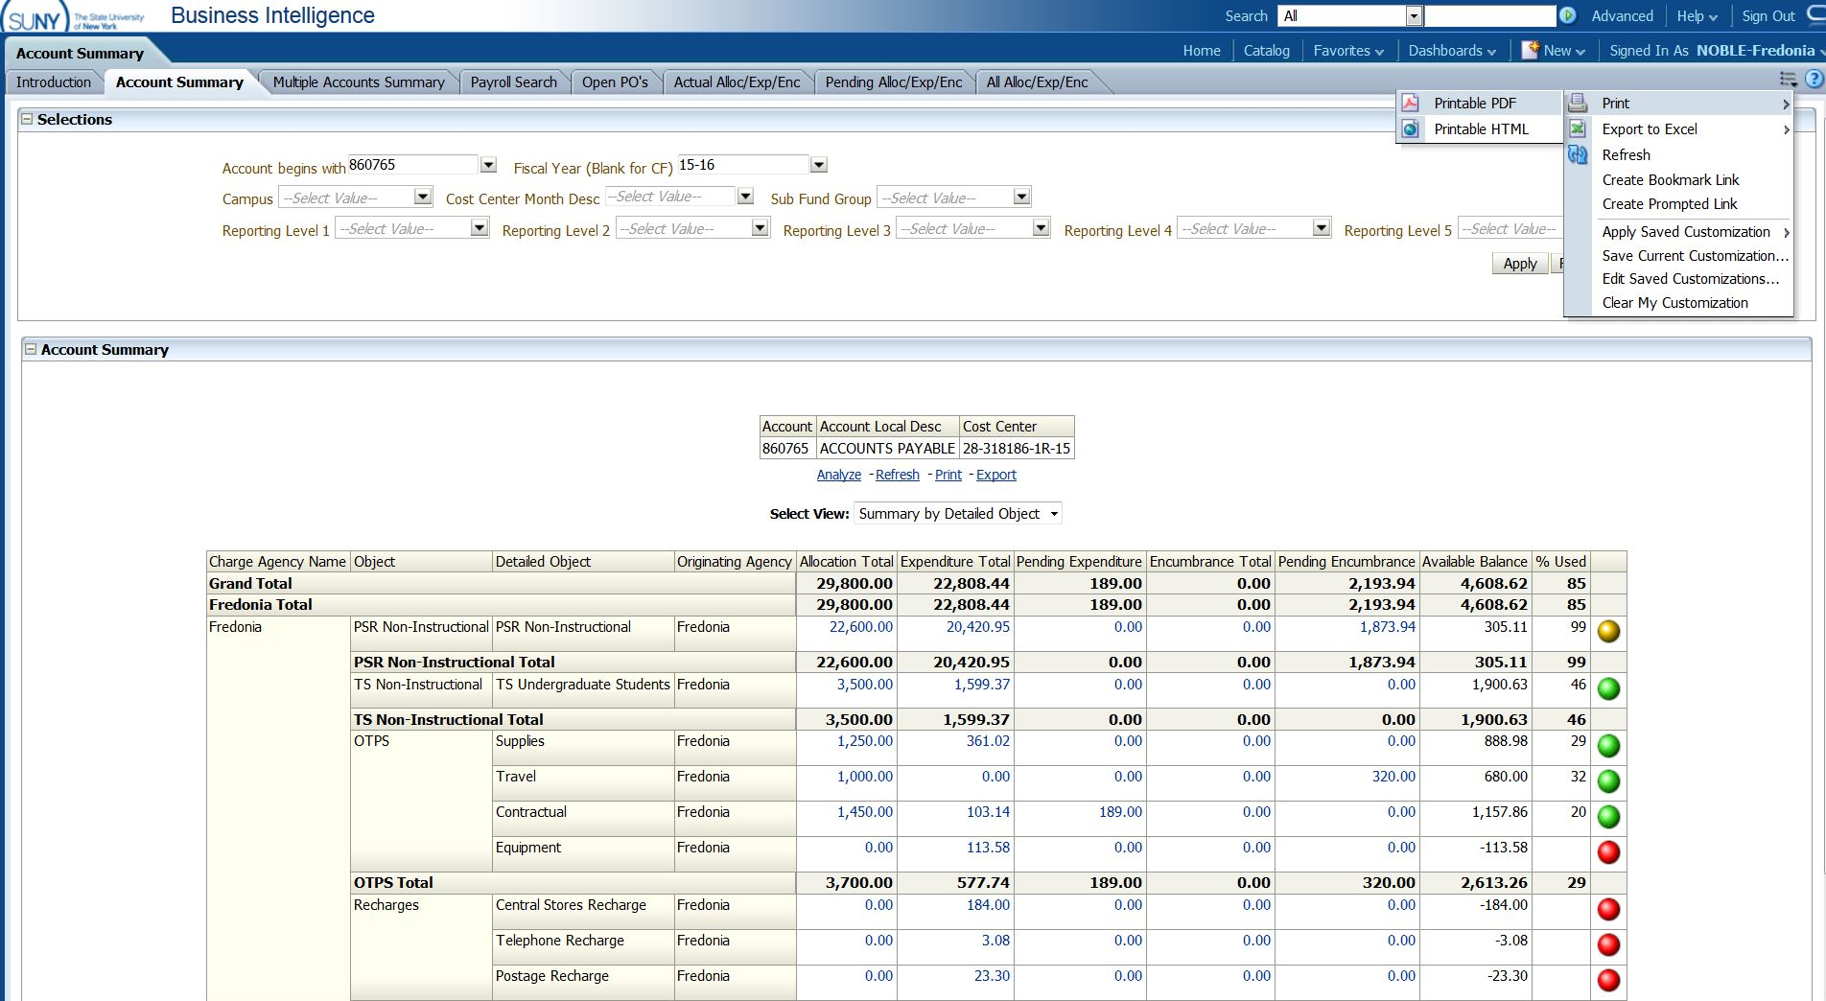

Choose “Save Current Customization”

Name your customization in popup window and click “OK”
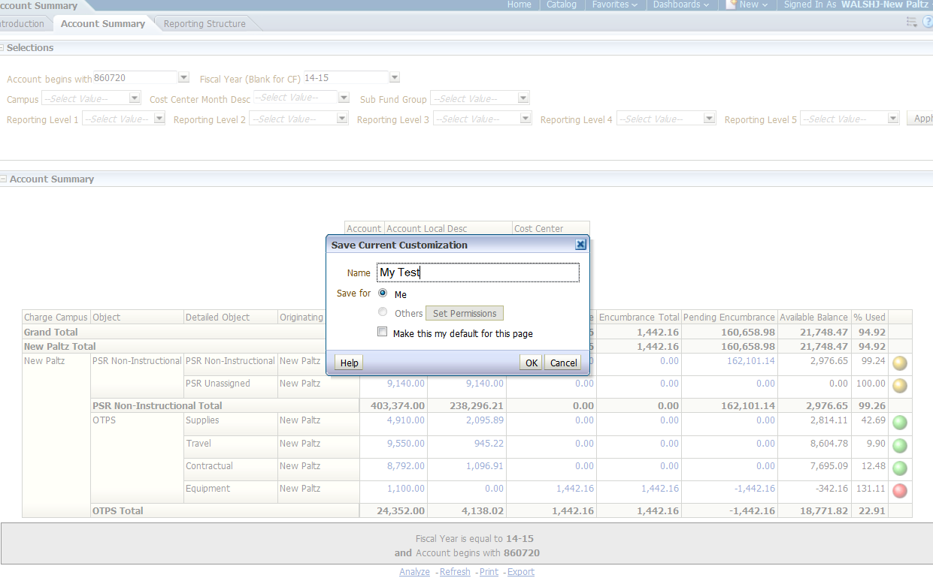

To open new customized page, go to account summary dashboard, click on Customization Toolbar
Then click on Apply Saved Customization / your customized dashboard

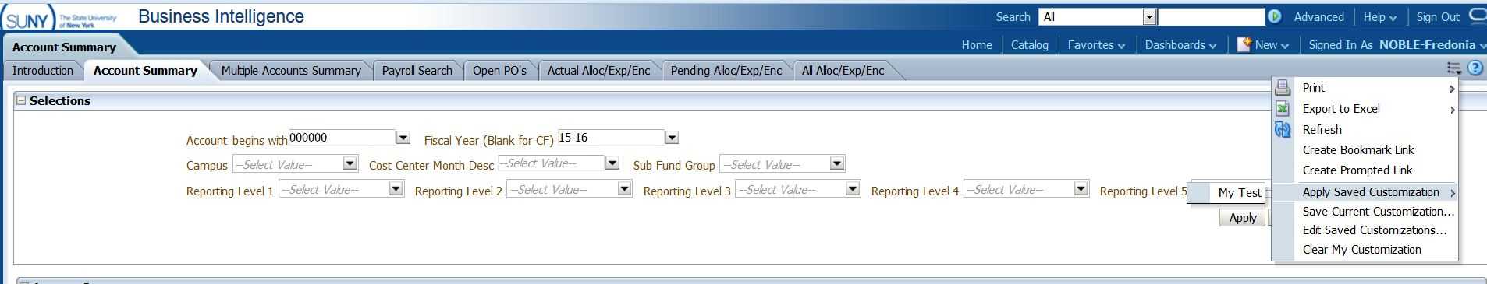
Your customized report will appear.

Other selections on selection box in Account Summary:
- Campus will always be Fredonia for most users, so field can be left blank
- Cost Center Month Desc - can choose a month end during the year to get a point-in-time snap shot for account
- Sub Fund Group - can choose all accounts under a specific funding source (depends on your access)
- Revenue Offset Fund – state operating accounts (prior to 2012, State Purpose Regular should be used)
- General IFR – state IFR accounts
- SUTRA – Summer accounts
- Dormitory Operations – Res Hall accounts
- Dormitory Sponsored – Res Hall IFR accounts
- Reporting Level 1 - can choose all accounts under a specific Vice President (depends on your access)
- Reporting Level 2 – can choose all accounts under a specific Director, AVP, or Dean (depends on your access)
- Reporting Level 3 – can choose all accounts under a specific Department (depends on your access)
- Reporting Level 4 & Reporting Level 5 - are currently not utilized
To utilize reporting level alone (no account), you can pull all accounts together in one report (summarize all accounts together). Account number must be blank so remove all zeros from account # or the query will not run. Choose the department under Reporting Level 3, you would like to see, then click “apply”

Account Summary Dashboard:

This Dashboard allows user to look for specific expenditures without having to know the account #
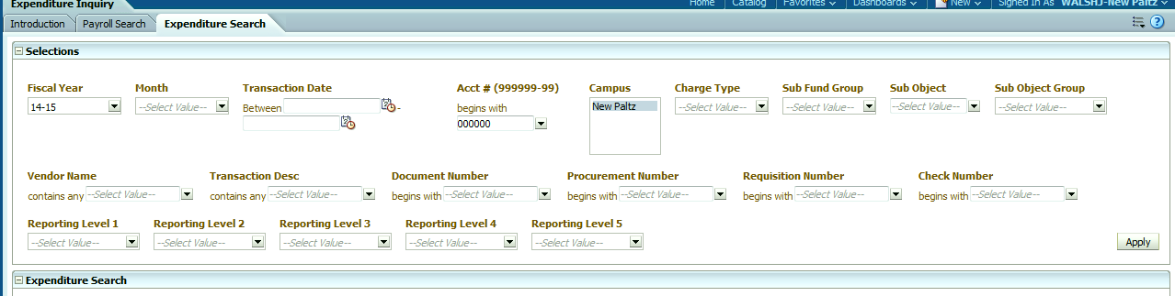

Data input includes:
- Fiscal Year
- Month
- Transaction dates
- Account Number
- Charge type
- Sub Fund group
- Sub Object
- Sub Object Group
- Vendor Name
- Transaction Desc
- Document number
- Procurement number
- Requisition Number
- Check Number
- Reporting levels

Click on Vendor Name / Search
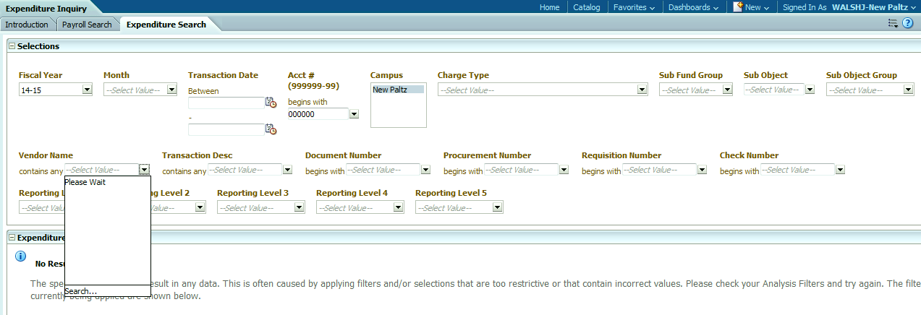
Type in vendor name, it’s best to click off Match Case if you don’t know if vendor name is in upper-case or not, click search.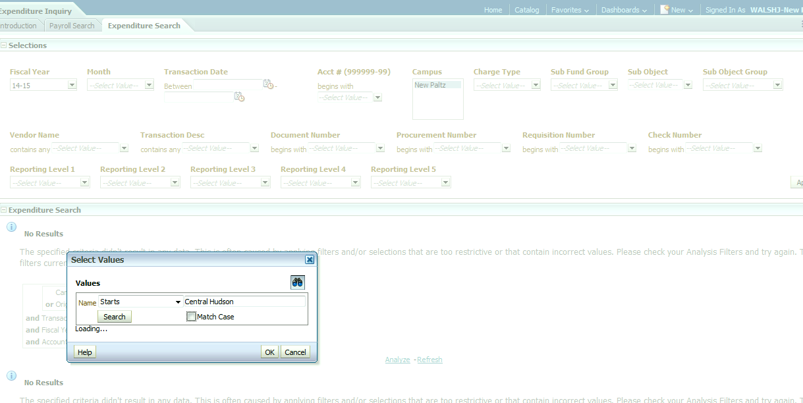

When found, select vendor name and click OK
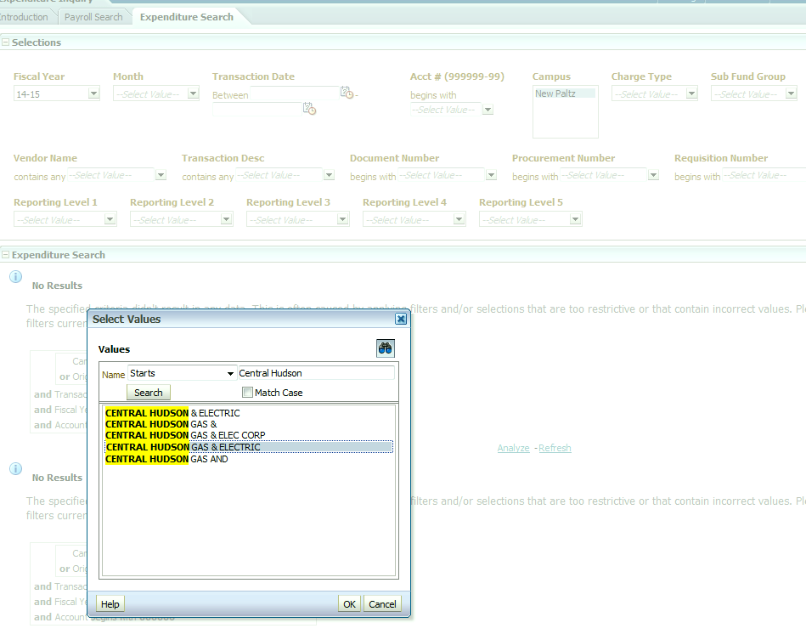

Make sure to clear out account number before hitting apply or your result will be blank.
Click Apply (may have to scroll over to the right to find button)

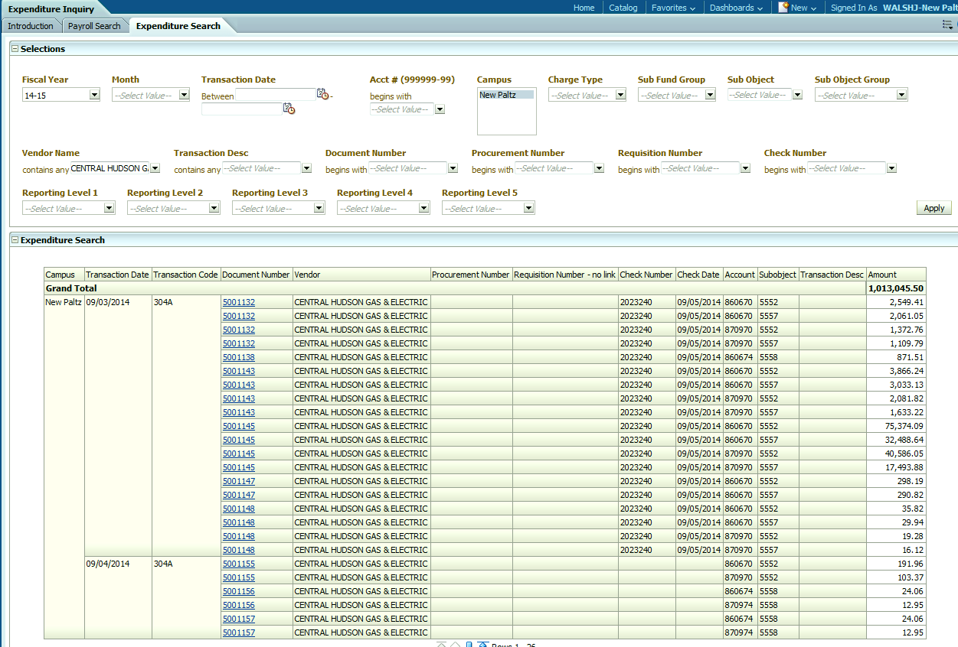

Results of search: Document number is drillable, clikc on blue document number to get Vendor Summary:
