6 Steps to Effective Note Taking:
- Divide the paper into three sections
- Draw a dark horizontal line a little more than one quarter of the paper length from the bottom. Highlight this line with a magic marker of highlighter to make sure it’s clear.
- Draw a dark vertical line about 2 inches from the left side of the paper, from the top to the horizontal line.

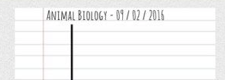
- Document
- At the top of each page, write down the course name and date.

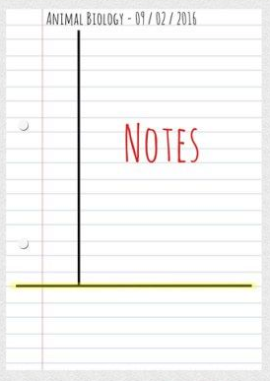
- Write Notes
- The large box on the right is for writing notes.
- Don’t write down complete sentences. Use abbreviations and bullet points if possible.
- Skip a line between ideas and topics.

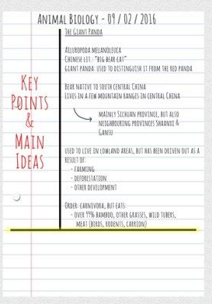
- Review & Clarify
- Review the notes as soon as possible after each class.
- Pull out main ideas, key points, dates and people and write these in the left column.

- Summarize
Write a summary of the main ideas in the bottom section.

- Study your Notes
- Re-Read your notes in the right column.
- Spend most of your time studying the ideas in the left column and the summary at the bottom. These are the most important ideas and will probably include most of the information that you will be tested on.

