Tying FREDmart and Tracker Together – When creating a requisition for items that need to go through the Tracker process for review by ITS and/or Contracts, we will be using three specific UNSPC Codes and the Specials Approvals Rule to route Requisitions to the appropriate department.

Complete the following steps in FREDmart to “link” FREDmart and Tracker together:

- Create a Requisition and a Tracker Ticket, simultaneously.

- Add a Comment, by clicking on the Comments/Business Purpose Tab
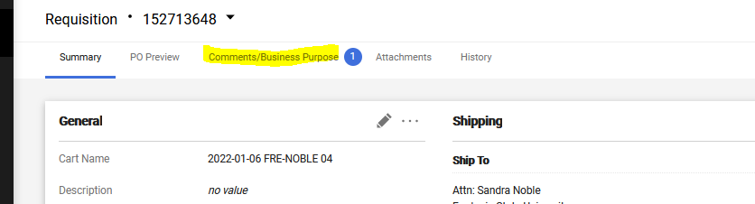

Click + (to Add a new Comment), type in Tracker Ticket Number, click 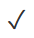(to Save Comment).
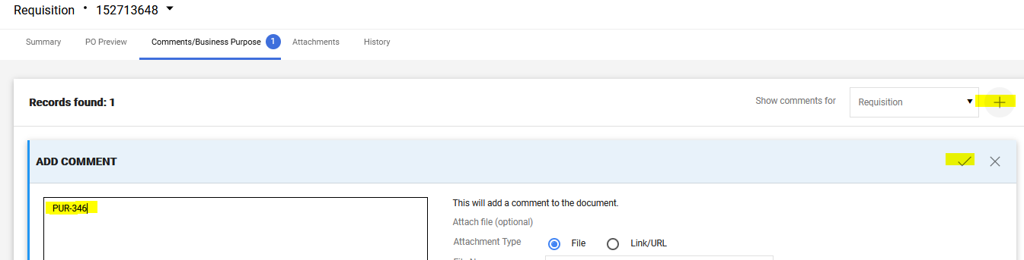

- Add FREDmart Requisition Number on the Tracker Ticket following the Technology Request Process (TRP).

- Scroll down to the bottom of the Requisition, to the Item(s) area. Click on the 3 dots and select SUNY Object
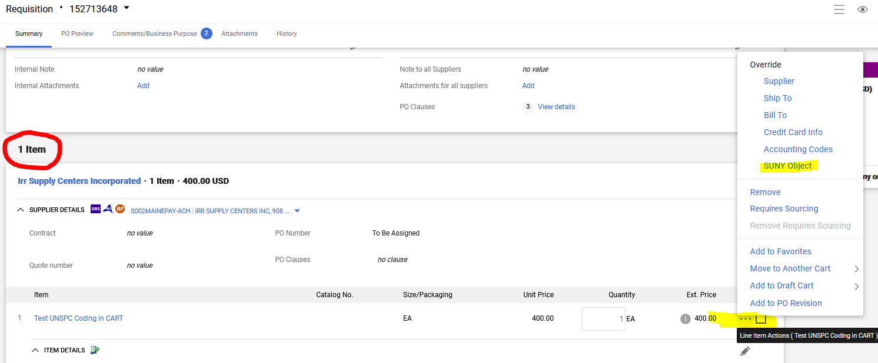

In the Override pop-up window, click on the magnifying glass:
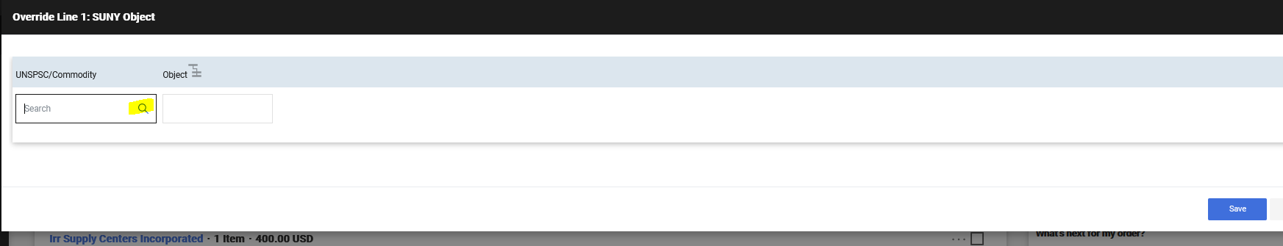

In the Custom Field Search pop-up window, type in one of THREE specific UNSPC Codes explained below and click Save.
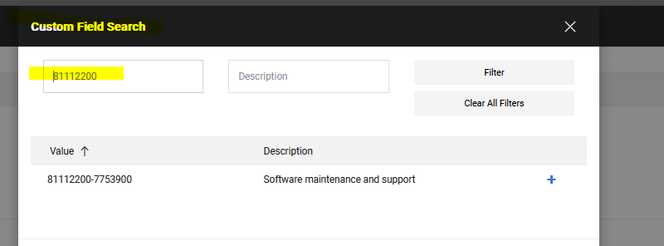

UNSPC Codes to use:
- Use UNSPC Code 43211507-7530200 when purchasing items that are for ITS approval only (such as hardware). This will route the FREDmart Requisition to ITS for their approval.
- Use UNSPSC code 64131500-1021300 when purchasing items that are for Contract approval only (such as busing services, contractor agreements, rental agreements). This will route the FREDmart Requisition to Contracts for approval.
- Use UNSPSC code 81112200-7753900 when purchasing items that require ITS, ISO, EIT, and Contracts approval (such as new or renewal of software, software as a service, cloud-based software). This will route the FREDmart requisition to ITS and Contracts for approval.

Shopping Tips:
User can leave the Object Code blank (unless using capital/construction funding).

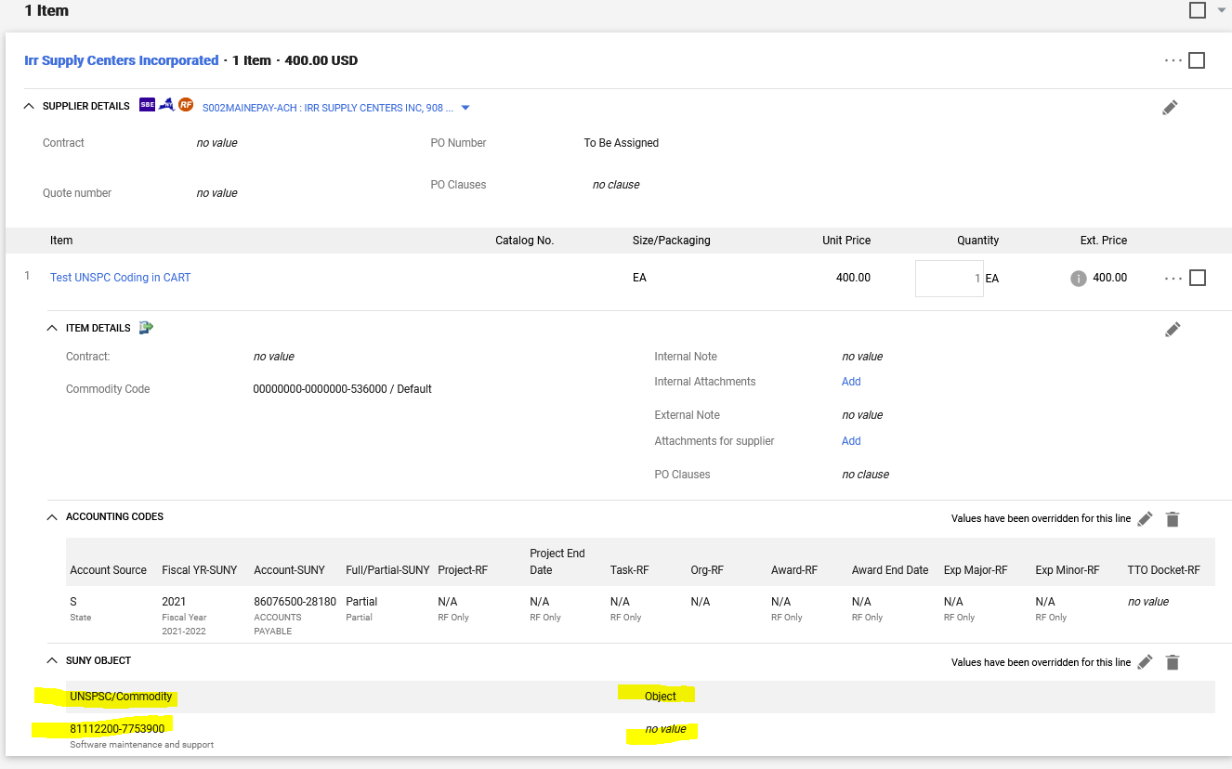

User should review What’s next for my order? (on the right), to confirm that their Requisition is “stopping” at the Special Approvals stop.

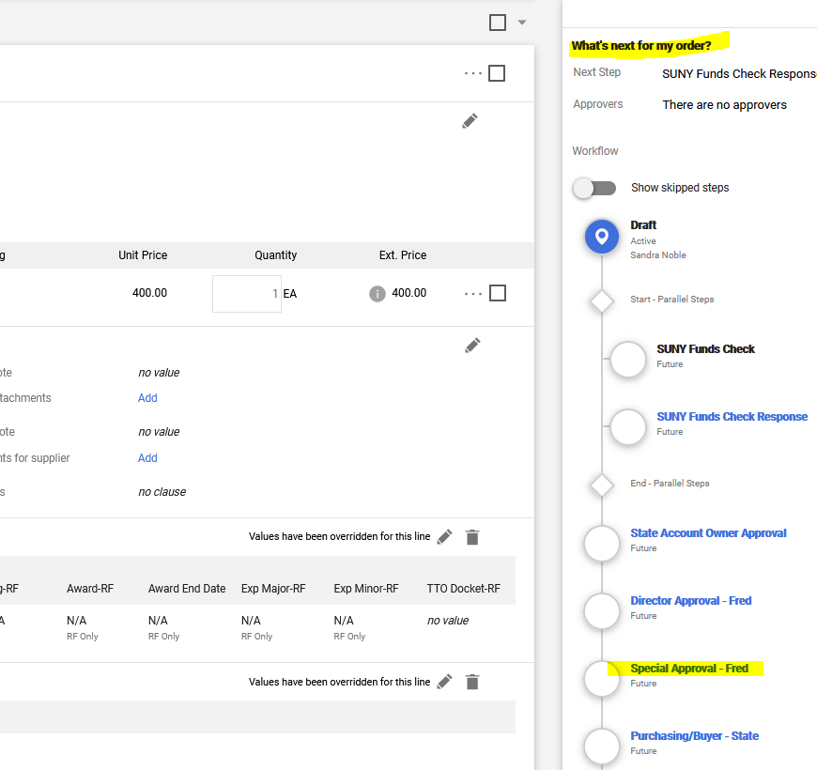

User should click on the Special Approval – Fred link to confirm the appropriate departments are listed. The departments listed should be the departments who will be approving the corresponding Tracker Ticket. This Example requires ITS and Contracts approval.
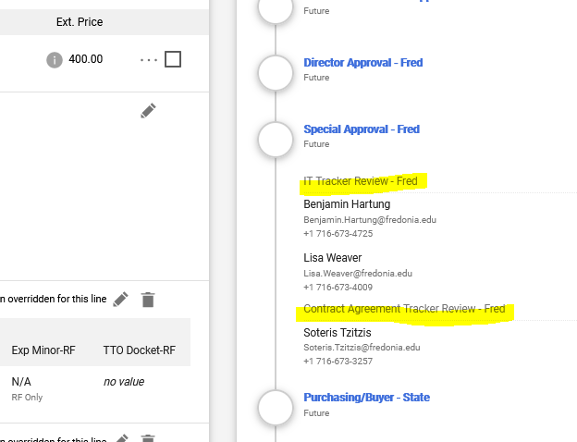

Please note: If an incorrect UNSPC Code is used and the Specials Approvals stop is not showing in the What’s next for my order? workflow, the Requisition will go directly to the Purchasing Department after VP Approval. The Buyer will have to Return the Requisition to the requisitioner. This workflow is automated, the Buyer cannot push the Requisition backwards in the workflow, simply by correcting the UNSPC Code. The Requisitioner will need to correct the UNSPC Code and start the approval process again.

