Shopping Overview
There are many ways to create orders in FREDmart. Users can submit a catalog order, non-catalog item order, and order using forms. This section will provide details on these different order types, so users can have a better understanding of what they are and which order type to use.
Ordering from the catalogs and using the Non-Catalog Form will be the two most popular ways users will create the majority of their orders.
- Catalog Orders - A catalog is a supplier’s product offering. There are two types of catalogs, hosted and punch out. Catalogs are found on the Home page under the Showcase section. These are described below.
- Hosted Catalog – In simplest terms, a hosted catalog is an online version of a supplier’s printed
catalog. Hosted catalogs are created and maintained by SUNY and contain product data and details, along with pricing information
for each item. When a product search is performed, the products in all of the hosted catalogs
are searched. Hosted catalog search results contain product information from all suppliers
depending on the search criteria entered by the user.
- Punch-out Catalogs – Punch-out catalogs are integrated EXTERNAL links to a supplier’s web-based catalog. Purch-out catalogs are crated and maintained by the supplier. The user exits the FREDmart application to search and select products from a supplier’s external web catalog, then returns the items to the FREDmart shopping cart. The selected items are then submitted through the standard requisition/order process. Punch-out products are NOT included in product search.

The first step is determining if the items you need to purchase are available from one of the catalogs. This can be done by clicking on the catalog.
Shopping Tip: Not certain where to find an item, use Shop Search – On the Shopping home screen, there is a search field at the top of the screen that lets users search all Hosted Catalogs and some Punch-out Catalogs.
Using Shop Search is a Best Practice, because user can search multiple catalogs at once.

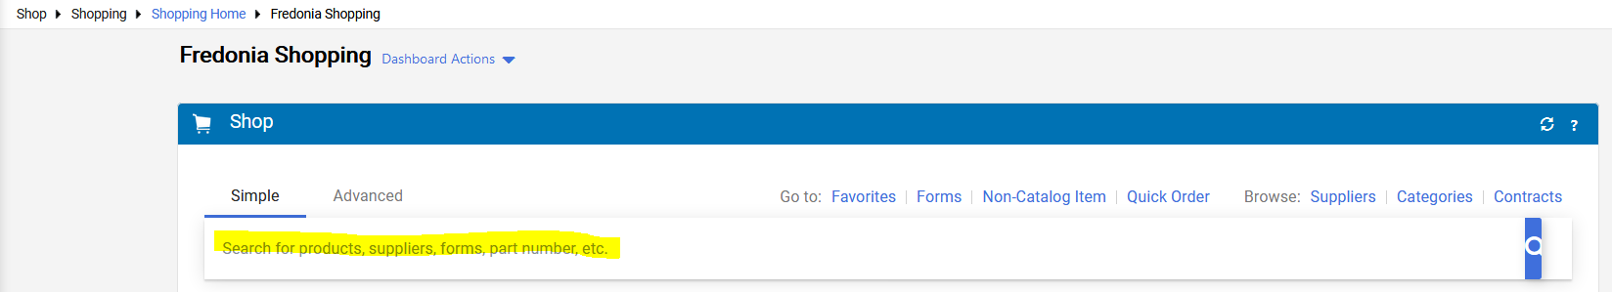
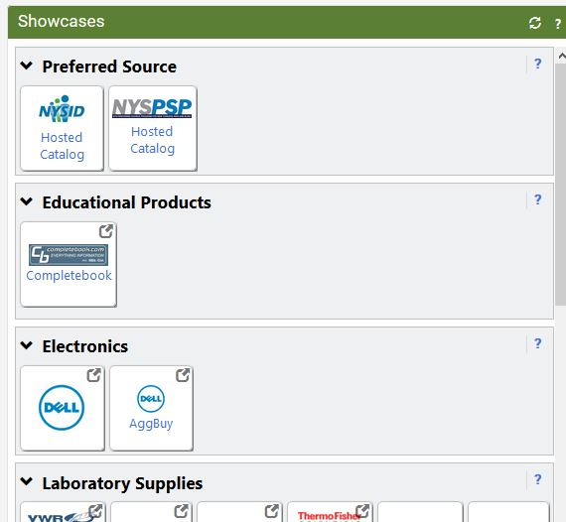

If the items you are purchasing are not found in a catalog, users will most likely then go to the Non-Catalog Form. However, some types of purchases may warrant the use of one of the Special Forms.
- Non-Catalog Item Orders – A non-catalog item order is an order for encumbered goods or services where there is not a hosted or punch-out catalog OR for items in which you receive special price quotes from a supplier. The non-catalog item order will send the supplier a purchase order. Non-Catalog Item Orders are created on the Home page under the Shop section.
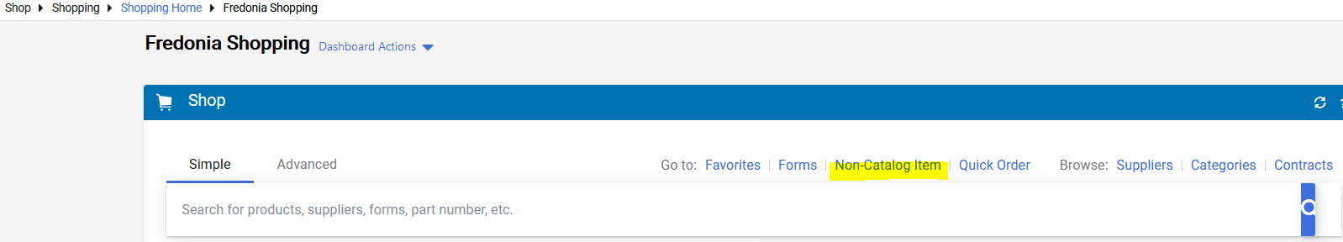

- Forms – Forms assist users with creating blanket orders and collecting the necessary information for specific types of non-encumbered payments. Forms are located on the Home page, at the bottom of the Showcase section under the Special Requests section. SUNY campuses have the ability to create and utilize different forms. FREDmart is currently using these forms:

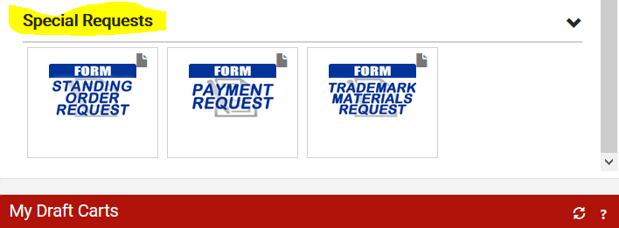

- Standing (Blanket) Order Request – This form is used to create orders that will (normally) be open for the entire fiscal year (July 1 through June 30). Departments and Buyers will work together to establish an annual encumbrance amount, based on the prior 2-3-year average. This form will create and send an external order to the supplier and encumber the expense.
- Payment Request - This form is used for payment of unencumbered goods such as dues and memberships or a one-time emergency service and repairs performed by a business entity (not an individual). FREDmart does not convert Payment Request Forms into an external order. User must have an invoice in-hand before using this form.
- Trademark Materials Request – This form must be used for any requests involving Campus logo imprinted materials. This includes; apparel, signage, banners, exact reprints, anything that has our logo. Form is also used when user needs artwork to be crated by the Publications Department. This form is routed to the Trademark and Licensing Committee and Publications Department.

All catalogs and forms are located on the Home page under the Showcase section.

